the delete statements only needs to take into account your primary key.

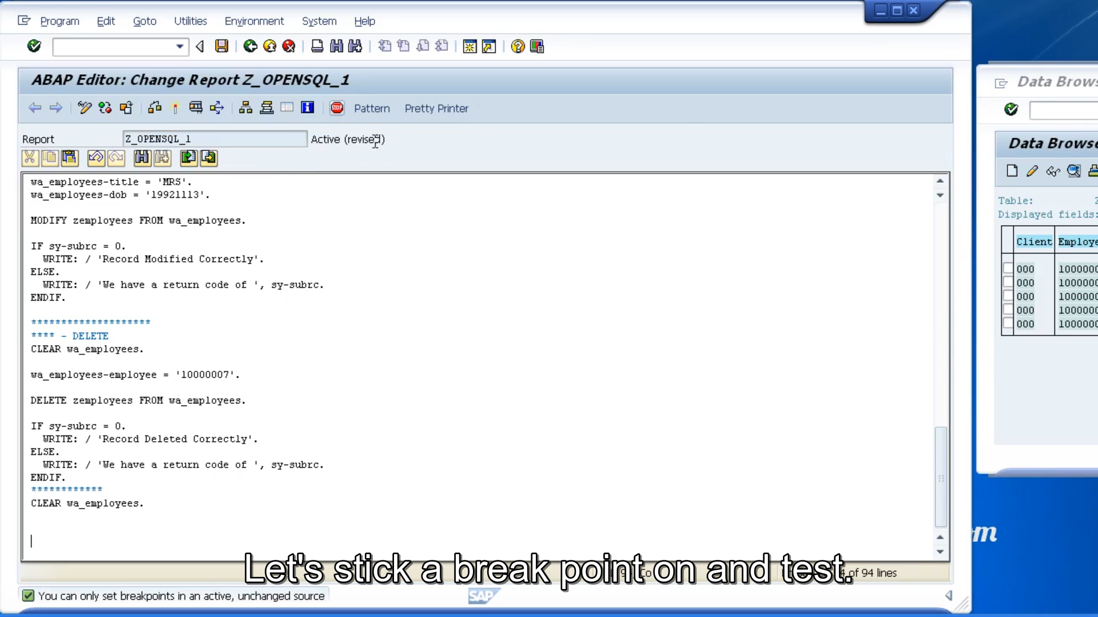

All we need to do is specify the employee number that we want to delete. So, let's go back to the table view and pop it to one side and back to our code. So, once we specify the employee number, we then just need to create our delete statement. The syntax for the delete statement is this, we have the DELETE, followed by the table name, followed by the from addition, followed by how a work area.

So, this delete statement will say DELETE zemployees FROM wa_employees. And wa_employees contain the table key 1 with 0s and 7 to ensure only that record identifies specifically in the work area, will be deleted from our table. And as per the other SQL statements, we need to check the SY sub RC field to make sure the record was deleted successfully.

Now, before moving on, let's have another look at the delete statement, but use a slightly different form. We're not just restricted to filling in the table key and deleting records that way. We can also use logic to determine which records we want to delete.

So, for example, let's create some more code.

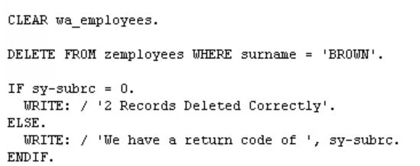

And we can choose to delete records on surname. So, if we say delete where surname equals Brown, then it should delete any records that have a surname of Brown. Now just to show that our example we'll delete more than one record.



And the last thing I just want to mention, is that if you used the delete statement in the following form, here we go, delete from z employees. This form of it is what I said earlier you need to be careful about. Because this will delete all the records on our table.